**Q1.**

10, 15, 2, 78, 92, 25 8, 41, 32, 21, 98, 33 ⟵

Your task is to: 1. Compare the elements of array1 with the elements of array2 as follows: • Compare the first element of array1 with the last element of array2. • Compare the second element of array1 with the second last element of array2. 2. If the element in array1 is greater than the corresponding element in array2, add the two elements and store the result in array3 at the same index. 3. If the element in array1 is less than or equal to the corresponding element in array2, store the average of the two elements in array3 at the same index. 4. Finally, print the contents of all three arrays: array1, array2, and array3.

**SOL**

#include <stdio.h>

int main() {

int array1[] = {10, 15, 2, 78, 92, 25};

int array2[] = {8, 41, 32, 21, 98, 33};

int array3[6];

int length = sizeof(array1) / sizeof(array1[0]);

for (int i = 0; i < length; i++) {

if (array1[i] > array2[length - 1 - i]) {

array3[i] = array1[i] + array2[length - 1 - i];

} else {

array3[i] = (array1[i] + array2[length - 1 - i]) / 2;

}

}

printf("Array 1: ");

for (int i = 0; i < length; i++) {

printf("%d ", array1[i]);

}

printf("\nArray 2: ");

for (int i = 0; i < length; i++) {

printf("%d ", array2[i]);

}

printf("\nArray 3: ");

for (int i = 0; i < length; i++) {

printf("%d ", array3[i]);

}

return 0;

}

**Output**

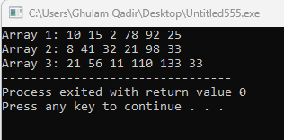

**Q2**

Write a C program that simulates rolling a single die multiple times based on user input. The program

should perform the following tasks:

1. Prompt the user for the number of times they want to roll the die. Validate that the input is a

positive integer.

2. Store the results of each roll in an array.

3. Calculate and display the total sum of all rolls.

4. For each roll, print:

A message indicating whether the roll was:

You rolled a six!

You rolled a one!

High roll!; if the value is 4 or greater.

Low roll. if the value is less than 4.

Hint: Random Number Generate

seed += 4

die = (seed * (i + 1) % 6) + 1

**SOL**

#include <stdio.h>

int main() {

int numRolls;

printf("How many times do you want to roll the die? ");

scanf("%d", &numRolls);

if (numRolls <= 0) {

printf("Please enter a positive integer for the number of rolls.\n");

return 1;

}

int rolls[numRolls];

int totalSum = 0;

int die;

int seed = 1;

int evenCount = 0;

int oddCount = 0;

for (int i = 0; i < numRolls; i++) {

seed += 4;

die = (seed * (i + 1) % 6) + 1;

rolls[i] = die;

totalSum += rolls[i];

printf("Roll %d: %d -> ", i + 1, rolls[i]);

if (die % 2 == 0) {

printf("You rolled an even number!\n");

evenCount++;

} else {

printf("You rolled an odd number!\n");

oddCount++;

}

}

printf("Total sum of all rolls: %d\n", totalSum);

printf("Total even rolls: %d\n", evenCount);

printf("Total odd rolls: %d\n", oddCount);

return 0;

}

**Output**

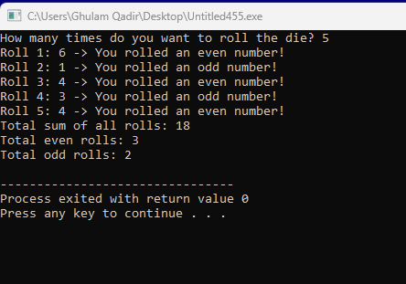

**Q3.**

Create a Car Rental System in C that allows customers to rent multiple cars, calculate the

total cost based on the selected car types and rental days, and print a final rental summary

before exiting. The system should use a do-while loop to continue taking rentals until the

customer decides to exit.

Requirements:

The system should display the following list of available car types:

1. Sedan - $50 per day

1. SUV - $100 per day

1. Luxury - $200 per day

1. Minivan - $80 per day

1. Print Rental Summary and Exit

Expected Output:

-------- Rental Summary --------

Total cars rented: 2

Total rental days: 5

Total amount to be paid: $350

Thank you for using the Car Rental System!

**SOL**

#include <stdio.h>

int main() {

int choice, rental_days;

int total_cars = 0;

int total_days = 0;

float total_cost = 0.0;

do {

printf("\n--------- Car Rental Menu ---------\n");

printf("1. Sedan - $50 per day\n");

printf("2. SUV - $100 per day\n");

printf("3. Luxury - $200 per day\n");

printf("4. Minivan - $80 per day\n");

printf("5. Print Rental Summary and Exit\n");

printf("----------------------------------\n");

printf("Enter your choice (1-5): ");

scanf("%d", &choice);

switch(choice) {

case 1:

printf("Enter the number of rental days for Sedan: ");

scanf("%d", &rental_days);

total_cost += 50.0 * rental_days;

total_cars++;

total_days += rental_days;

printf("Sedan rented for %d day(s). Running total: $%.2f\n", rental_days, total_cost);

break;

case 2:

printf("Enter the number of rental days for SUV: ");

scanf("%d", &rental_days);

total_cost += 100.0 * rental_days;

total_cars++;

total_days += rental_days;

printf("SUV rented for %d day(s). Running total: $%.2f\n", rental_days, total_cost);

break;

case 3:

printf("Enter the number of rental days for Luxury: ");

scanf("%d", &rental_days);

total_cost += 200.0 * rental_days;

total_cars++;

total_days += rental_days;

printf("Luxury car rented for %d day(s). Running total: $%.2f\n", rental_days, total_cost);

break;

case 4:

printf("Enter the number of rental days for Minivan: ");

scanf("%d", &rental_days);

total_cost += 80.0 * rental_days;

total_cars++;

total_days += rental_days;

printf("Minivan rented for %d day(s). Running total: $%.2f\n", rental_days, total_cost);

break;

case 5:

printf("\n-------- Rental Summary --------\n");

printf("Total cars rented: %d\n", total_cars);

printf("Total rental days: %d\n", total_days);

printf("Total amount to be paid: $%.2f\n", total_cost);

printf("Thank you for using the Car Rental System!\n");

break;

default:

printf("Invalid choice. Please select a valid option.\n");

}

} while (choice != 5); /

return 0;

}